Year 8 |  | Ratio Rates and Proportion | Non Calculator  Section
- Recognise and solve problems involving simple ratios (ACMNA173)  - Solve a range of problems involving rates and ratios, with and without digital technologies (ACMNA188)  - Investigate, interpret and analyse graphs from authentic data (ACMNA180 ) |  |  | Name___________________
Answer all questions in the spaces provided on this test paper by:
Writing the answer in the box provided.
or
Shading in the bubble for the correct answer from the four choices provided.
Show any working out on the test paper. Calculators are not allowed.
Questions 1 – 2 refer to the following.
On a table there are some mugs and some glasses.
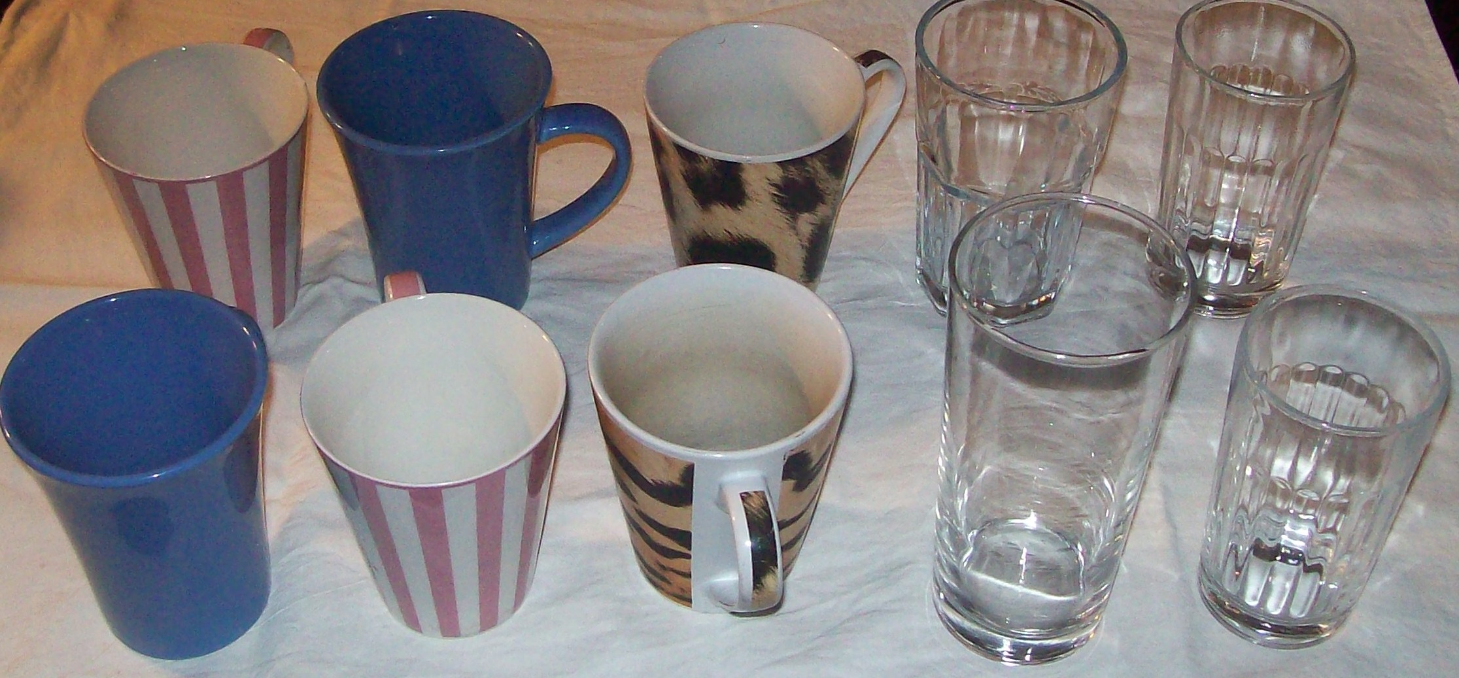

 | What is the ratio of mugs to glasses in simplest form?
The cupboard has mugs and glasses in the same ratio as shown above.
There are 18 mugs in the cupboard.
How many glasses are there in the cupboard?

glasses.

The cupboard holds only mugs and glasses.

What fraction of the cupboard’s contents are mugs?

Freya has 18 trophies on her shelf. Twelve of them are for netball and the rest are for dancing.
The ratio of netball trophies to dancing trophies is:

1 : 2 2 : 1 2 : 3 3 : 2

The ratio 8 : 20 when written in simplest form is:

2 : 3 2 : 5 5 : 2 3 : 5

A harvester covers a 120 hectare paddock in 5 hours. What is this as a rate in hectares per hour?

ha/h.

A car travels at 45 km/h. How far would it travel in 8 hours?

km.

 | Dina has 50 books, 15 of which are biographies and the rest are novels. What is the ratio of biographies to novels? (answer in simplest form)
Which ratio is equivalent to 3 : 4?

4 : 6 6 : 5 9 : 16 12 : 16

 | Write the ratio 36 : 16 in simplest form.
Complete the statement below.

40 : 30 = 16 :

 | Write the ratio 4.5 : 1.5 in simplest form.
 | Divide 200 in the ratio 3 : 2.
A car travels 120 km using 12 litres of fuel.
What is the rate of use in km/litre?

6 km/litre. 8 km/litre. 10 km/litre. 12 km/litre.

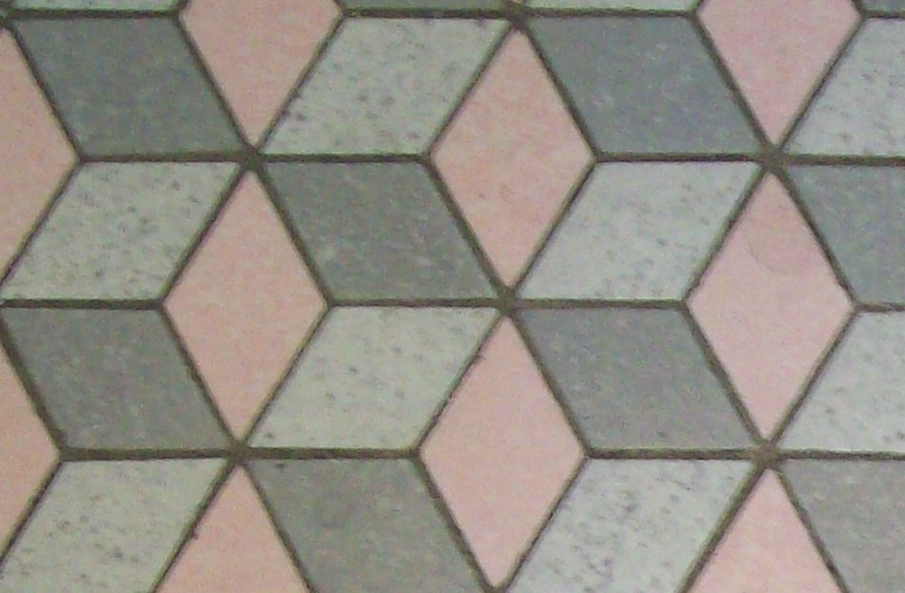
A tiler can lay 12 m²/hour. How long would it take to lay an area of 66 m²?

hours.

What is the ratio 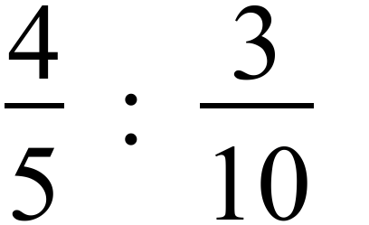 in simplest form?

2 : 3 3 : 4 4 : 3 8 : 3

What is the ratio 30 minutes : 1¼ hours in simplest form ?

3 : 4 3 : 5 2 : 5 45 : 75

 | Divide 800 marbles in the ratio 9: 1.
Three kilograms of cherries is divided between Ken and Leo in the ratio 4 : 1. How many grams of cherries does Ken get?

600 g 750 g 2 000 g 2 400 g

Marcie mixes concrete which consists of sand, aggregate and cement in the ratio 5 : 3 : 1.
If she needs 36 buckets of concrete how many buckets of sand will she need?

4 buckets.

12 buckets.

20 buckets.

24 buckets.

Year 8 |  | Ratio Rates and Proportion | Calculator Allowed  Short Answer  Section
 |  |  | Name___________________
Answer all questions in the spaces provided on this test paper by:
Writing the answer in the box provided.
or
Shading in the bubble for the correct answer from the four choices provided.
Show any working out on the test paper. Calculators are allowed.
In a town there are 400 adults and 250 children.
What is the ratio of adults to children in simplest form?

Complete the statement below.

24 : 32 = 3 :

What is the ratio 1.25 : 0.5 in simplest form?

2 : 5 5 : 2 5 : 20 50 : 2

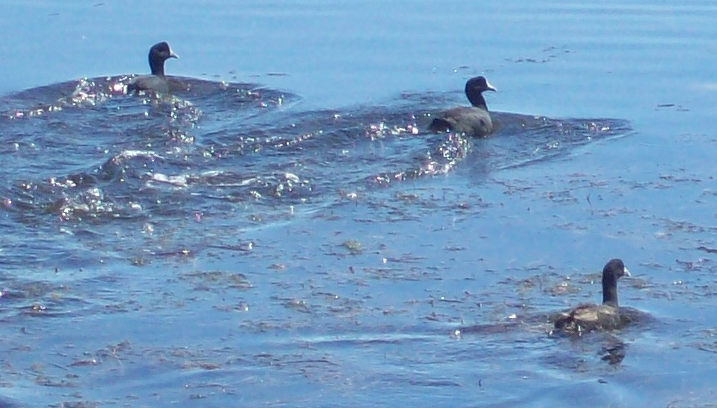
The ratio of ducks to swans on a lake is 15 : 7.
There are 110 ducks and swans in total on the lake.
How many ducks are there?

To mix a liquid fertiliser, the label says to mix 45 g of fertiliser in a 9 litre watering can of water. What is this as a rate in g/L?

5 g/L 9 g/L 15 g/L 405 g/L

Eddie worked out that the time he spent at home and at work was in the ratio 6: 5 respectively.
He spent 45 hours at work.
How many hours did he spend at home?

hours

A map has a scale of 1 : 20 000.
Liza measures the distance between two houses on the map to be 12 cm.
How far apart are the houses?

1.2 km 2.4 km 4.8 km 12 km

The ratio 500 g : 1.5 kg in simplest form, without using units, is;

1 : 2 1 : 1.5 1 : 3 1 : 5

Mitchell is a cricketer who has a bowling strike rate of 4.5 wickets/innings.
How many wickets did he get if he played 20 innings?

wickets

Tara is laying carpet tiles in her house and it takes her 6 hours to lay 45 m² of carpet tiles.
At what rate did she lay the tiles?

m²/hour

Amber records how she spends 8 hours at work one day.
She spend the time filing, typing and copying in the ratio 6 : 7 : 3.
How long did she spend typing?

2 hours 2.5 hours 3 hours 3.5 hours

Which of these ratios is equivalent to 5 : 14?

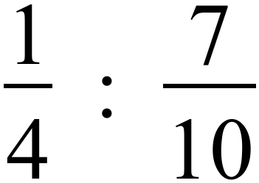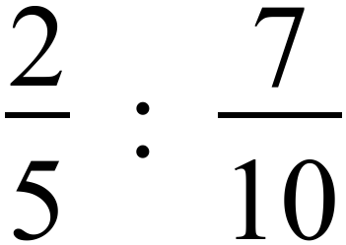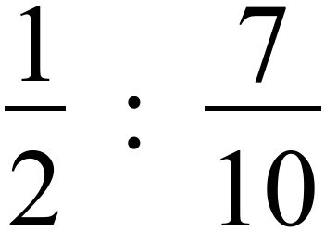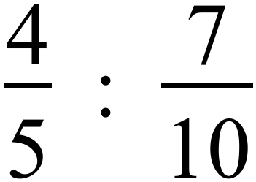

 | Luke has scored at a rate of 18 points/game for his footy team. If he has scored 342 points, how many games has he played?
Deanna drives her car a distance of 450 km at an average speed of 90 km/h.
How much less time would the journey have taken if she had averaged 100 km/h?

It would take minutes less.

Questions 15 and 16 refer to the following.
The distance-time graph represents Thomas’ journey from home in Melbourne to Bendigo for a meeting and then back home.
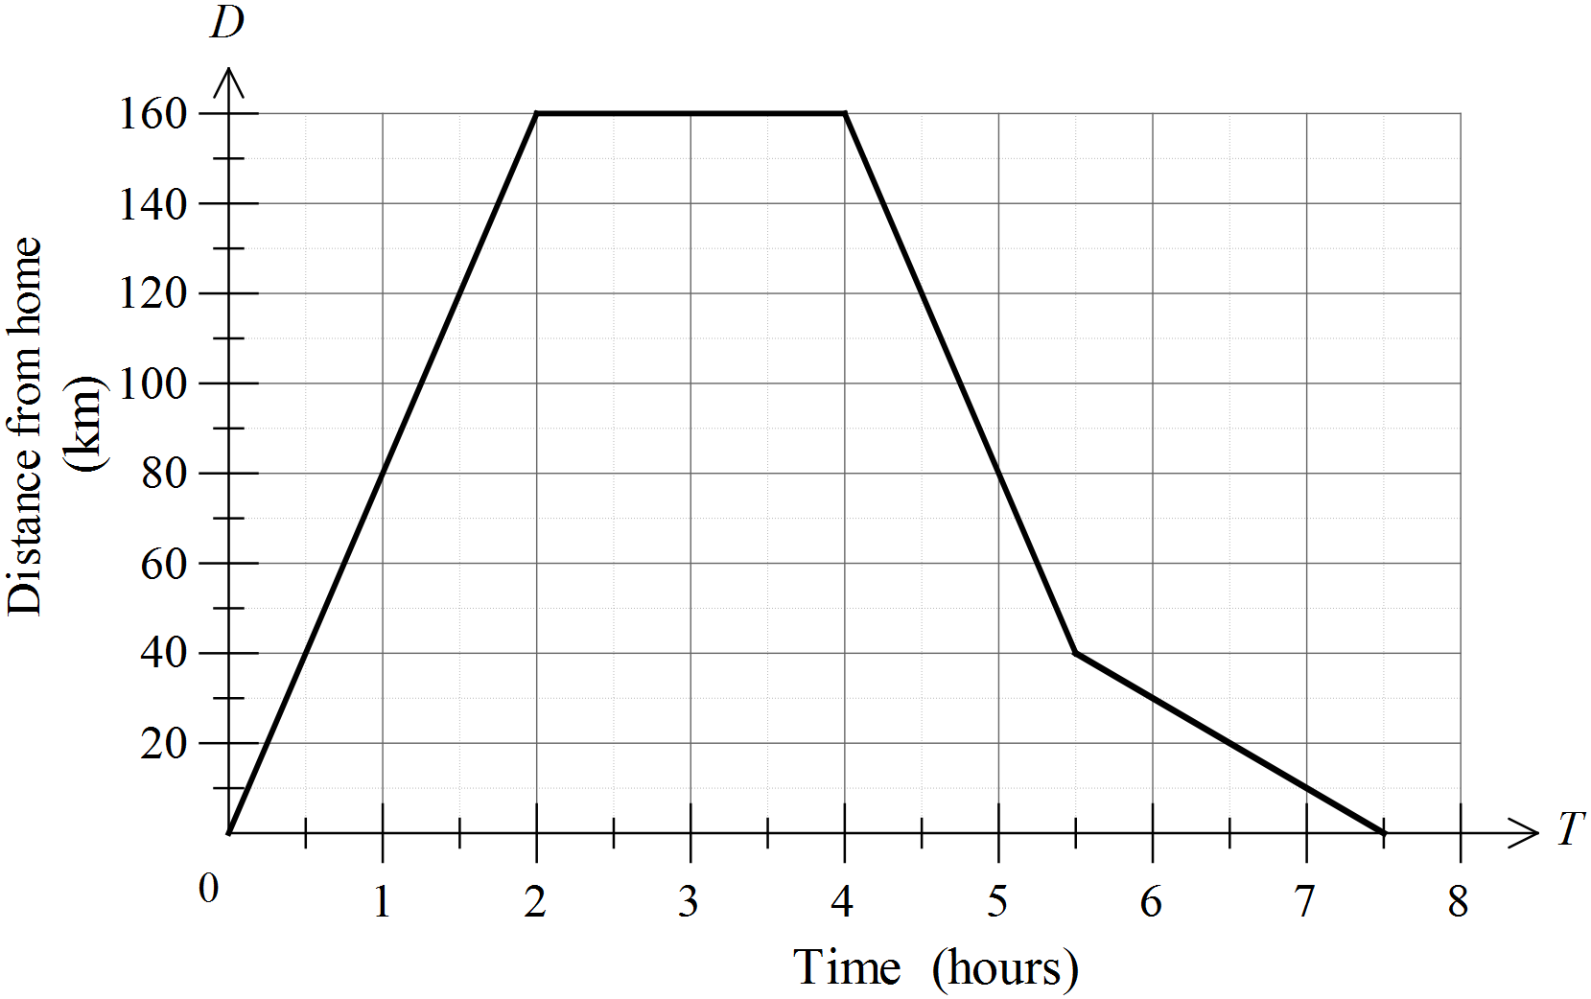

How long did Thomas stay in Bendigo?

1 hour 1.5 hours 2 hours 4 hours

At what average speed did Thomas travel on his way to Bendigo?

km/h.

On his journey home, he had a good run until heavy traffic slowed his journey.
How far from home was he when he met the heavy traffic?

km from home.

By how much was his speed lowered by the heavy traffic?

The speed dropped from 90 km/h to 10 km/h.

The speed dropped from 80 km/h to 10 km/h.

The speed dropped from 90 km/h to 20 km/h.

The speed dropped from 80 km/h to 20 km/h.

Ratio Rates and Proportion
ANSWERS
Non Calculator Section ( 1 mark each)

Q no |  | Answer
 | M : G = 6 : 4 = 3 : 2
M : G = 3 : 2 = 18 : G
Times by 6 to get new ratio.
Number of glasses = 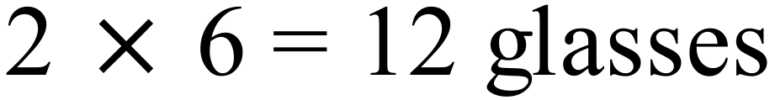
Ratio is M : G = 18 : 12
Total is 30
Fraction which are mugs = 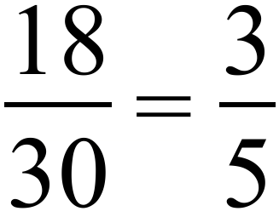

 | Ratio N : D = 12 : 6 = 2 : 1 | 2nd Answer
 | 8 : 20 = 2 : 5 | 2nd Answer
 | Rate = 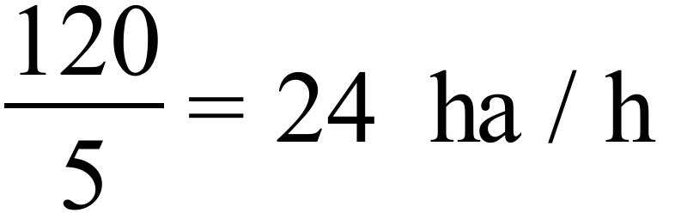
 | 45 km/h in 8 hrs travels 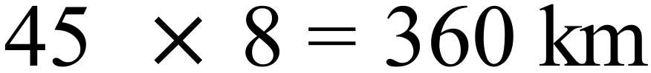
 | B : N = 15 : (50-15) = 15 : 35 = 3 : 7
 | The last one is equivalent. | 4th Answer.
 | 36 : 16 = 9 : 4
 | 40 : 30 = 4 : 3 = 16 : 12
 | 4.5 : 1.5 = 45 : 15 = 3 : 1.
 | 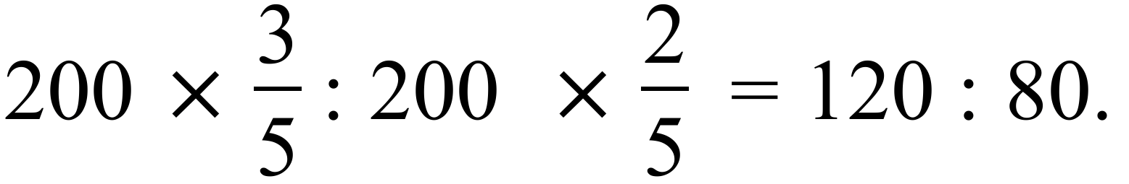
 | 120 km using 12 litres = 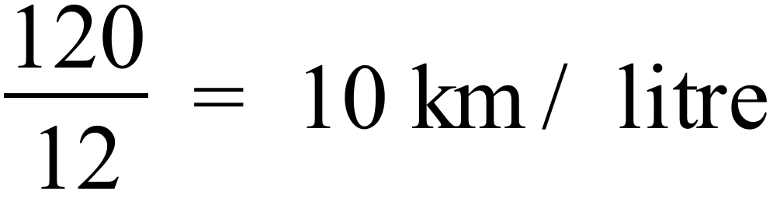 | 3rd Answer
 | 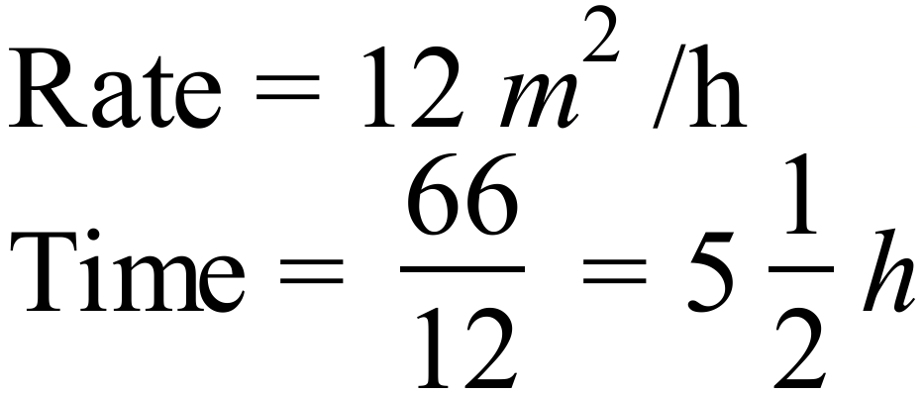
 | 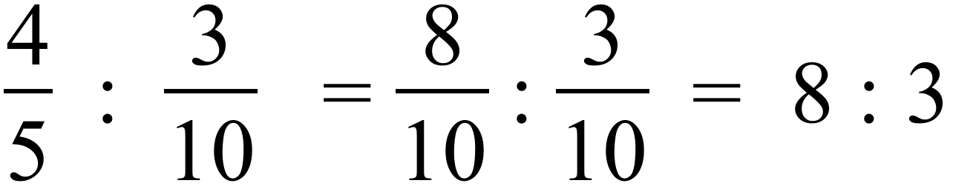 | 4th Answer
 | 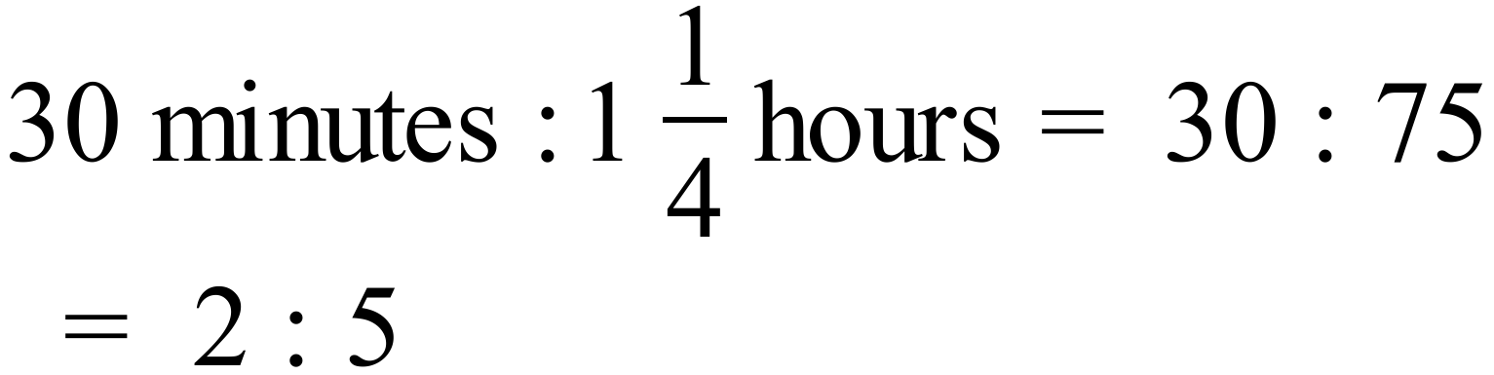 | 3rd Answer
 | 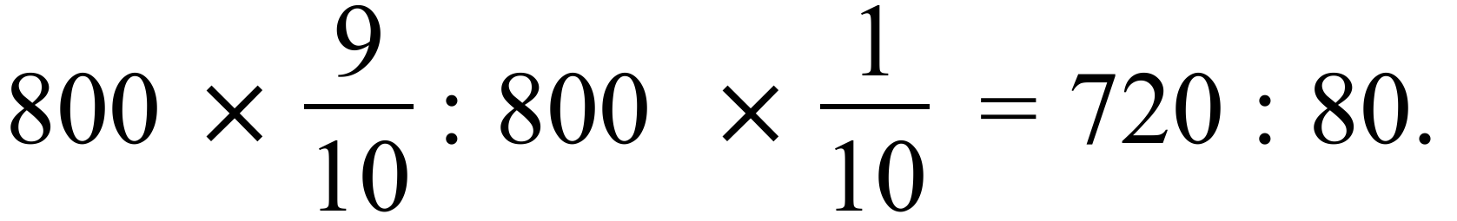
 | 3 kg = 3000g  Ken gets  of them.  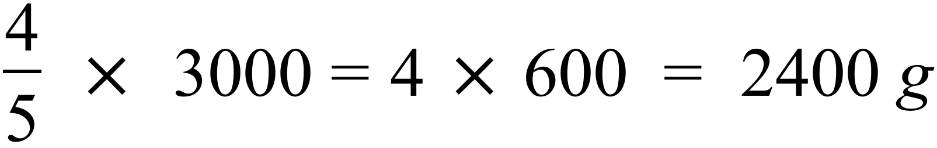 | 4th Answer
 | 36 buckets of concrete is 4 times the total of the contents(9 parts).  Amount of sand = | (3rd Answer)

Calculator Allowed Short Answer Section ( 1 mark each)

Q no |  | Answer
 | 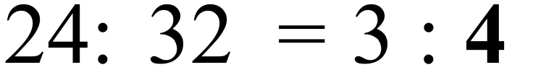
 | 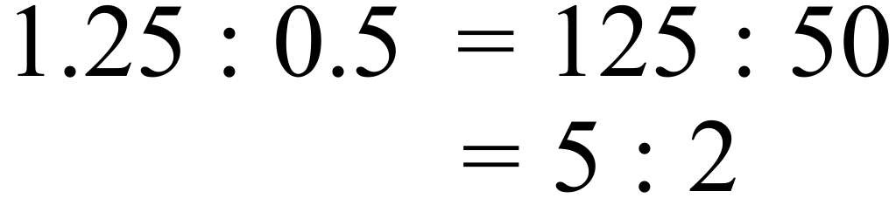 | (2nd Answer)
 | 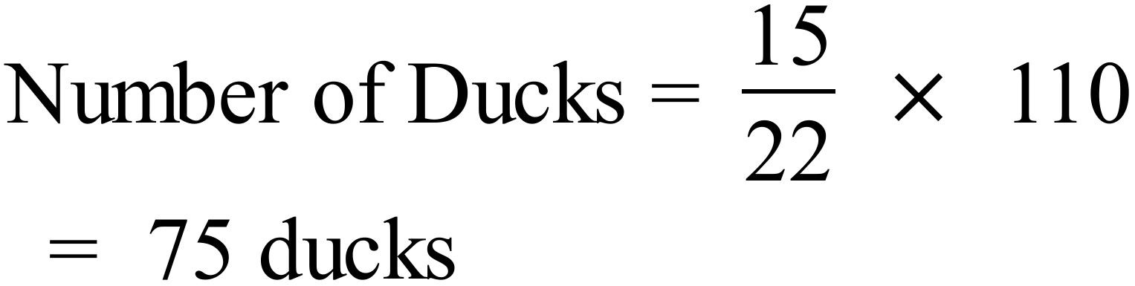
 |  | (1st Answer)
 | 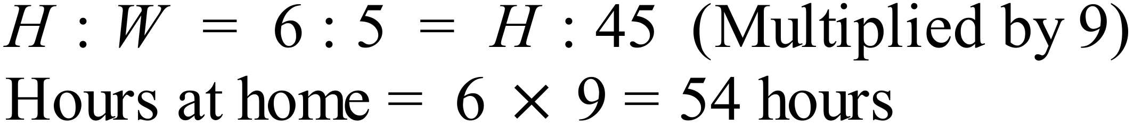
 | Real distance is 20 000 times the map distance.  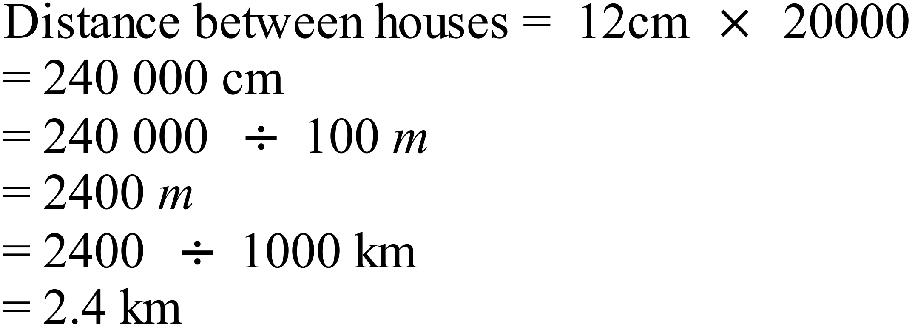 | (2nd Answer)
 | 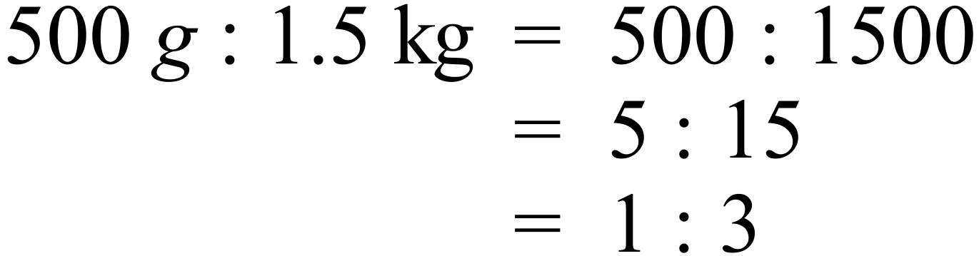 | (3rd Answer)
 | 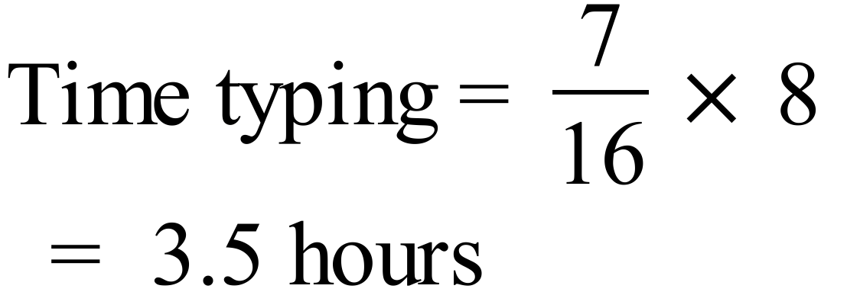 | 4th Answer
 | 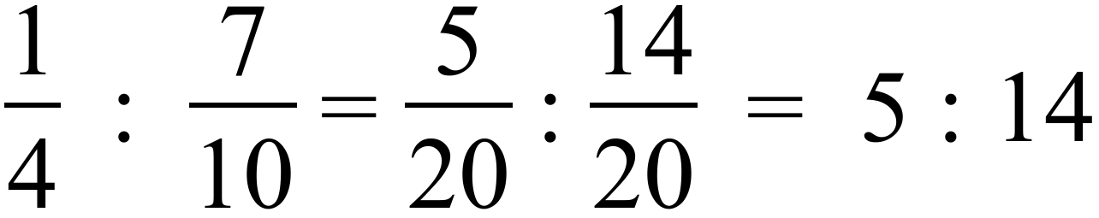 | (1st Answer)
 | 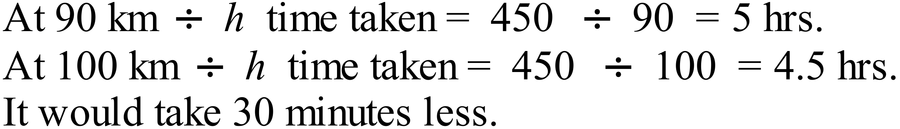
 | 2 hours | (3rd Answer)
 | 40 km from home ( when gradient of line changes)
 | 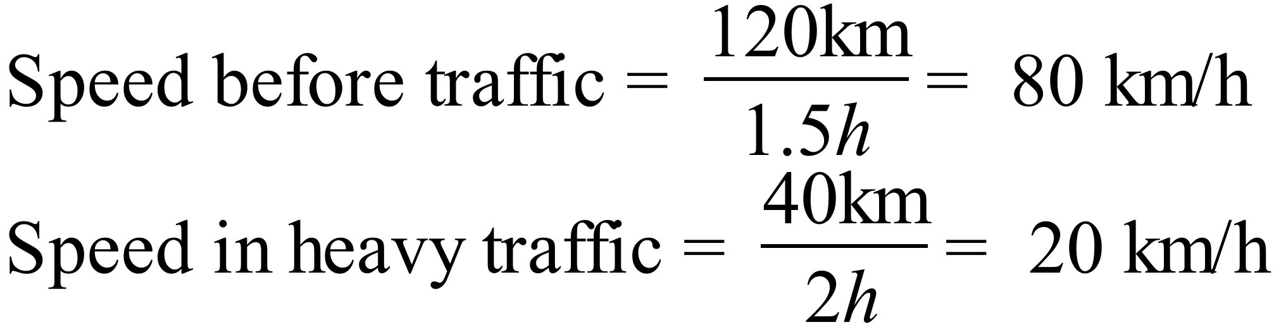 | 4th Answer

